LAB 2

1. Design a page that contains the syllabus of Web Technology using the concept of ordered and unordered list.

<!DOCTYPE html>

<html lang="en">

<head>

  <meta charset="UTF-8">

  <meta name="viewport" content="width=device-width, initial-scale=1.0">

  <title>Course Description</title>

</head>

<body>

 <p> <strong>Course Description : </strong>This course introduces basic elements of the design and analysis of computer algorithms. Topics include asymptotic notations and analysis, divide and conquer strategy, greedy methods, dynamic programming, basic graph algorithms, NP-completeness, and approximation algorithms. For each topic, beside in-depth coverage, one or more representative problems and their algorithms shall be discussed. </p>

 <br>

 <h2>Course Objective</h2>

 <ul>

    <li> Analyze the asymptotic performance of algorithms.</li>

    <li> Demonstrate a familiarity with major algorithm design techniques</li>

    <li> Apply important algorithmic design paradigms and methods of analysis. </li>

    <li> Solve simple to moderately difficult algorithmic problems arising in applications.</li>

    <Li> Able to demonstrate the hardness of simple NP-complete problems</Li>

 </ul>

 <h2>Course Content :</h2>

 <h2>Unit 1:Foundation of Algorithm Analysis(4)</h2>

  <p>1.1. Algorithm and its properties, RAM model, Time and Space Complexity, detailed analysis

  of algorithms (Like factorial algorithm), Concept of Aggregate Analysis</p>

  <p>1.2. Asymptotic Notations: Big-O, Big-Ω and Big-Ө Notations their Geometrical Interpretation

      and Examples.</p>

  <p>1.3. Recurrences: Recursive Algorithms and Recurrence Relations, Solving Recurrences

     (Recursion Tree Method, Substitution Method, Application of Masters Theorem)</p>

   <h2>Unit 2:Iterative Algorithm(4)</h2>

   <p>2.1. Basic Algorithms: Algorithm for GCD, Fibonacci Number and analysis of their time and

     space complexity</p>

   <p>2.2. Searching Algorithms: Sequential Search and its analysis</p>

   <p>2.3. Sorting Algorithms: Bubble, Selection, and Insertion Sort and their Analysis</p>

</body>

</html>

OUTPUT

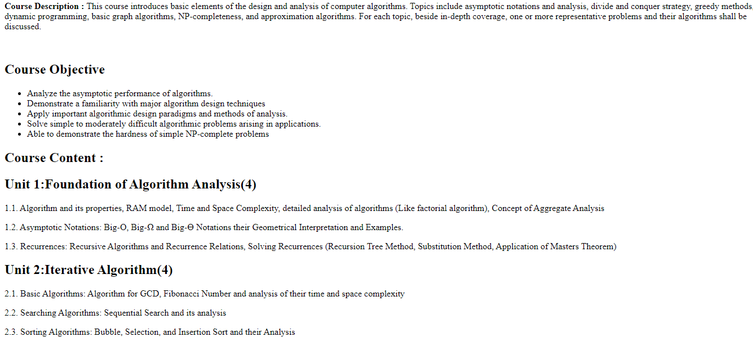

1. Prepare the restaurant menu using List tag and heading tags. Also apply some sorts of formatting in the menu. (you can also use table tag to generate the menu).

<!DOCTYPE html>

<html lang="en">

<head>

    <meta charset="UTF-8">

    <meta name="viewport" content="width=device-width, initial-scale=1.0">

    <title>Document</title>

    <style>

        th,td

        {

            width: 2%;

        }

        table

        {

            border-radius: 10px;

            border-style: groove;

            font-size: larger;

        }

    </style>

</head>

<body>

    <div>

        <table>

       <th style="text-align: center;" colspan="3.5">CHINESE</th>

            <tr>

               <th style="text-align:left;" colspan="2">SOUPS-VEG</td>

               <th style="text-align:left;" colspan="2">STARTERS-VEG</td>

            </tr>

            <tr>

                <td>Swweet Corn Soup</td>

                <td>125</td>

                <td>Veg Crispy</td>

                <td>225</td>

            </tr>

            <tr>

                <td>Mushroom Soup</td>

                <td>130</td>

                <td>Veg Noodles</td>

                <td>195</td>

            </tr>

            <tr>

                <td>Hot and Sour Soup</td>

                <td>110</td>

                <td>Veg Pizza</td>

                <td>200</td>

            </tr>

            <tr>

                <td>Noodles Soup</td>

                <td>90</td>

                <td>Veg Spring Roll</td>

                <td>300</td>

            </tr>

            <tr>

                <td>Chicken Flavour Soup</td>

                <td>410</td>

                <td>Mushroom Chilly</td>

                <td>500</td>

            </tr>

            <tr>

                <th style="text-align: left;" colspan="2">SOUPS-NONVEG</td>

                <td>Butter Garlic Mushroom</td>

                <td>210</td>

            </tr>

            <tr>

            <td>Chicken Noodles Soup</td>

            <td>145</td>

            <td>Crispy Garlic Mushroom</td>

            <td>500</td>

            </tr>

            <tr>

                <td>Mutton Noodles Soup</td>

                <td>145</td>

                <td>Crispy Garlic </td>

                <td>200</td>

                </tr>

                <tr>

                    <td>Chicken Thai Soup</td>

                    <td>145</td>

                    <td>Crispy Roasted Mushroom</td>

                    <td>500</td>

                    </tr>

                    <tr>

                        <td>Chicken Sweet Corn Soup</td>

                        <td>145</td>

                        <td>Mushroom Chilly</td>

                        <td>300</td>

                        </tr>

                        <tr>

                            <td>Chicken Rice Soup</td>

                            <td>145</td>

                            <td>Crispy Garlic Baby</td>

                            <td>500</td>

                            </tr>

                            <tr>

                                <td>Butter Garlic Mushroom</td>

                                <td>210</td>

                                <th style="text-align: left;" colspan="3">STARTERS NONVEG</td>

                            </tr>

                            <tr>

                                <td>Fish Soup</td>

                                <td>145</td>

                                <td>Chicken Chilly</td>

                                <td>300</td>

                                </tr>

                                <tr>

                                    <td>Sea Food Soup</td>

                                    <td>245</td>

                                    <td>Chicken Crispy</td>

                                    <td>260</td>

                                    </tr>

                                    <tr>

                                        <td>Chicken Lemon Soup</td>

                                        <td>245</td>

                                        <td>Chicken Hot Pot</td>

                                        <td>500</td>

                                        </tr> <tr>

                                            <td>Chicken Yum Yum Soup</td>

                                            <td>690</td>

                                            <td>Crispy Garlic Baby</td>

                                            <td>500</td>

                                            </tr>

        </table>

    </div>

</body>

</html>

OUTPUT

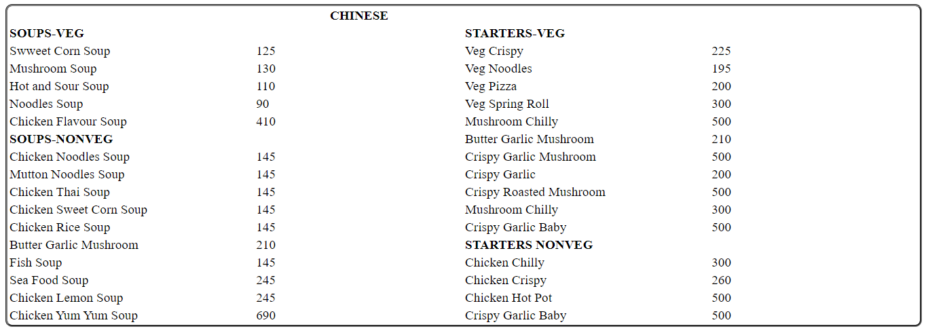

1. Use HTML to create a Mark-Sheet as shown in figure.

<!DOCTYPE html>

<html lang="en">

<head>

  <meta charset="UTF-8">

  <meta name="viewport" content="width=device-width, initial-scale=1.0">

  <title>Document</title>

  <style>

    p{

      display: inline;

    }

    table,th,td

    {

      border: 1px solid black;

      border-collapse: collapse;

    }

    hr

    {

      border-top: 1 px solid black;

    }

    .sign-table

    {

      border: hidden;

    }

    .dashed

    {

      border-top: 1px dashed black;

    }

  </style>

</head>

<body style="margin: 0 15%;border-style: solid;">

  <h2 style="text-align: center;">First Terminal Examination</h2>

  <h3 style="background-color: #03fcad;text-align: center;"><u>PROGRESS REPORTSHEET</u></h3>

  <div>

    <p style="margin-left: 5px;">Name of STUDENT</p>

    <P style="margin-left: 50%;">REGD NO</P>

  </div>

  <div>

  <p style="margin-left: 15px;">CLASS</p>

  <p style="margin-left: 50%;">ROLL NO</p>

</div>

<div class="result-table">

  <table width ="100%">

    <thead>

      <tr>

        <th colspan="2" rowspan="2">SUBJECT</th>

        <th rowspan="2">CR HR</th>

        <th colspan="4">MARKS IN TERM 50%</th>

        <th rowspan="2">CAS 50%</th>

        <th rowspan="2">REMARKS</th>

      </tr>

      <tr>

        <th>FULL MARKS</th>

        <th>PASS MARKS</th>

        <th>FINAL GRADE</th>

        <th>GRADE POINT</th>

      </tr>

      <tr>

        <td cellpadding="2" colspan="2">1 Nepali</td>

        <td>4</td>

        <td>50</td>

        <td>30</td>

        <td>B</td>

        <td>2.8</td>

        <td>A</td>

        <td></td>

      </tr>

      <tr>

        <td cellpadding="2" colspan="2">2 English</td>

        <td>4</td>

        <td>50</td>

        <td>40</td>

        <td>A+</td>

        <td>4.0</td>

        <td>A</td>

        <td></td>

      </tr>

      <tr>

        <td cellpadding="2" colspan="2">3 Mathematics</td>

        <td>4</td>

        <td>50</td>

        <td>32</td>

        <td>B</td>

        <td>2.8</td>

        <td>B</td>

        <td></td>

      </tr>

      <tr>

        <td cellpadding="2" colspan="2">4 Science</td>

        <td>4</td>

        <td>50</td>

        <td>38</td>

        <td>B+</td>

        <td>3.2</td>

        <td>B</td>

        <td></td>

      </tr>

      <tr>

        <td cellpadding="2" colspan="2">5 Social Studies</td>

        <td>4</td>

        <td>50</td>

        <td>24</td>

        <td>C</td>

        <td>2.0</td>

        <td>B</td>

        <td></td>

      </tr>

      <tr>

        <td cellpadding="2" colspan="2">6 Computer Science/GK</td>

        <td>4</td>

        <td>50</td>

        <td>44</td>

        <td>A</td>

        <td>3.6</td>

        <td>B</td>

        <td></td>

      </tr>

      <tr>

        <td cellpadding="2" colspan="2">7 English Language</td>

        <td>4</td>

        <td>50</td>

        <td>42</td>

        <td>A</td>

        <td>3.6</td>

        <td>B</td>

        <td></td>

      </tr>

    </thead>

  </table>

</div>

<div>

  <p><strong>TOTAL</strong></p>

  <p style="margin-left: 15%;">28</p>

  <p style="margin-left: 5%;">350</p>

  <p style="margin-left: 10%;">255</p>

</div>

<hr class="dashed">

<div>

  <p><strong>GRADE POINTS AVERAGE(GPA):</strong></p>

  <p style="margin-left: 45%;">3.14</p>

</div>

<hr class="dashed">

<div>

<p><strong>AVERAGE GRADE</strong></p>

<p style="margin-left: 58%;">B+</p>

</div>

<hr>

<div style="width: 100%; position:relative;"></div>

<ul style="list-style-type: none;padding-left: 0px;width: 30%";>

<li><strong>Percentage</strong> 91.5</li>

<li><strong>Poisiton</strong> 1</li>

<li><strong>Total Student</strong> 20</li>

<li><strong>Attendance:</strong> 0/0</li>

</ul>

<div style="position: absolute; left:390px; top: 434px;">

  <table>

    <thead>

      <tr>

        <th colspan="2">GRADE DESCRIPTION CAS</th>

      </tr>

    </thead>

    <tbody>

      <tr>

        <td>Interval in Percent</td>

        <td>GRADE</td>

      </tr>

      <tr>

        <td>70 to 100</td>

        <td>A</td>

      </tr>

      <tr>

        <td>40 to 70</td>

        <td>B</td>

      </tr>

      <tr>

        <td>0 to below 40</td>

        <td>C</td>

      </tr>

    </tbody>

  </table>

</div>

<div style="position: absolute; right: 220px;top:440px;">

<table>

  <thead>

    <tr>

      <th colspan="3">Grade Description in Terms</th>

    </tr>

  </thead>

  <tbody>

    <tr>

      <td>Interval in Percent</td>

      <td>Grade</td>

      <td>Grade Point</td>

    </tr>

    <tr>

      <td>90 to 100</td>

      <td>A+</td>

      <td>4.0</td>

    </tr>

    <tr>

      <td>80 to 90</td>

      <td>A</td>

      <td>3.6</td>

    </tr>

    <tr>

      <td>70 to 80</td>

      <td>B+</td>

      <td>3.2</td>

    </tr>

    <tr>

      <td>60 to 70</td>

      <td>B</td>

      <td>2.8</td>

    </tr>

    <tr>

      <td>50 to 60</td>

      <td>C+</td>

      <td>2.4</td>

    </tr>

    <tr>

      <td>40 to 50</td>

      <td>C</td>

      <td>2.0</td>

    </tr>

    <tr>

      <td>30 to 40</td>

      <td>D+</td>

      <td>1.6</td>

    </tr>

  </tbody>

</table>

</div>

<div style="margin: 5%;">

<p><strong>REMARKS</strong></p>

<span>Very Good</span>

</div>

<div style="margin: 5px 10px 5px; padding-right: 0;">

<table width ="100%"class="sign-table">

  <tr>

    <td class="sign-table">

      <hr style="border-top: 2px solid black;width: 60%;text-align: left;margin-left: 5px;">

      <span style="margin-left: 30px;">CHECKED BY</span>

    </td>

    <td class="sign-table">

      <hr style="border-top: 2px solid black;width: 60%;text-align: left;margin-left: 5px;">

      <span style="margin-left: 30px;">CLASS TEACHER</span>

    </td>

    <td>

      <hr style="border-top: 2px solid black;width: 60%;text-align: center;margin-left: 5px;">

      <span style="margin-left: 30px;">PRINCIPAL</span>

    </td>

  </tr>

</table>

</div>

</body>

</html>

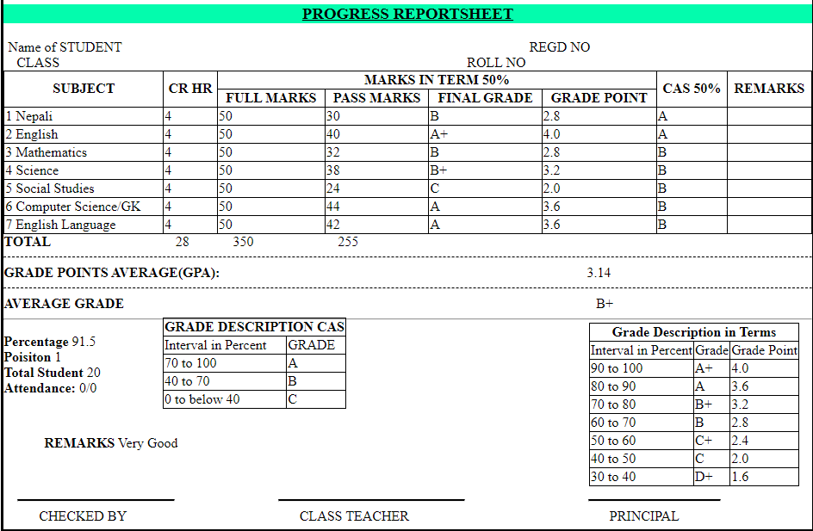OUTPUT

1. Design your classroom routine to implement the Table element of HTML.

<!DOCTYPE html>

<html lang="en">

<head>

  <meta charset="UTF-8">

  <meta name="viewport" content="width=device-width, initial-scale=1.0">

  <style>

    table th,td{

      border: 1px solid black;

      border-collapse: collapse;

    }

  </style>

  <title>Routine</title>

</head>

<body>

  <h1>Routine BSC CSIT 5th SEM 2077</h1>

  <table>

    <thead>

      <tr>

        <th>

          <th>Sunday</th>

          <th>Monday</th>

          <th>Tuesday</th>

          <th>Wednesday</th>

          <th>Thursday</th>

          <th>Friday</th>

        </th>

      </tr>

    </thead>

    <tbody>

      <tr>

        <td>11:15 - 12:15</td>

        <td>Simulation</td>

        <td>SAD</td>

        <td>Simulation</td>

        <td>SAD</td>

        <td>Simulation</td>

        <td>SAD</td>

      </tr>

      <tr>

        <td rowspan="2">12:15 - 01:15</td>

        <td style="background-color:grey;">Simulation Grp'A'</td>

        <td rowspan="2">Cryptograhy</td>

        <td style="background-color:grey;">Simulation Grp'B'</td>

        <td style="background-color:grey;">Simulation Grp'A'</td>

        <td rowspan="2">Cryptograhy</td>

        <td style="background-color:grey;">Simulation Grp'B'</td>

      </tr>

      <tr>

        <td style="background-color:grey;">SAD Grp'B'</td>

        <td style="background-color:grey;">SAD Grp'A'</td>

        <td style="background-color:grey;">SAD Grp'B'</td>

        <td style="background-color:grey;">SAD Grp'A'</td>

      </tr>

      <tr>

        <td>1:15 - 1:30</td>

        <td colspan="6" style="background-color:grey;"><strong>SHORT BREAK</strong></td>

      </tr>

      <tr>

        <td rowspan="2">1:30 - 02:30</td>

        <td style="background-color:grey;">Multimedia Grp'B'</td>

        <td style="background-color:grey;">Multimedia Grp'A'</td>

        <td rowspan="2">Multimedia</td>

        <td rowspan="2">Multimedia</td>

        <td style="background-color:grey;">Multimedia Grp'A'</td>

        <td rowspan="2">Multimedia</td>

      </tr>

      <tr>

        <td style="background-color:grey;">Cryptograhy Grp'A'</td>

        <td style="background-color:grey;">Cryptograhy Grp'B'</td>

        <td style="background-color:grey;">Cryptograhy Grp'A'</td>

      </tr>

      <tr>

        <td>2:30 - 3:00</td>

        <td colspan="6" style="background-color:grey;"><strong>LUNCH BREAK</strong></td>

      </tr>

      <tr>

        <td rowspan="2">3:00 - 4:00</td>

        <td rowspan="2">WebTech</td>

        <td style="background-color:grey;">WebTech Grp'B'</td>

        <td style="background-color:grey;">Cryptograhy Grp'A'</td>

        <td style="background-color:grey;">WebTech Grp'A'</td>

        <td style="background-color:grey;">WebTech Grp'B'</td>

        <td rowspan="2">WebTech</td>

      </tr>

      <tr>

        <td style="background-color:grey;">DAA Grp'A'</td>

        <td style="background-color:grey;">Multimedia Grp'B'</td>

        <td style="background-color:grey;">DAA Grp'B'</td>

        <td style="background-color:grey;">DAA Grp'A'</td>

      </tr>

      <tr>

        <td rowspan="2">4:00 - 5:00</td>

        <td style="background-color:grey;">WebTech Grp'A'</td>

        <td rowspan="2">DAA</td>

        <td rowspan="2">DAA</td>

        <td rowspan="2">Cryptograhy</td>

        <td rowspan="2">WebTech</td>

        <td rowspan="2">DAA</td>

      </tr>

      <tr>

        <td style="background-color:grey;">DAA Grp'B'</td>

      </tr>

    </tbody>

  </table>

  <p>Th: Theory</p>

  <p>Pr:Practical Group</p>

</body>

</html>

OUTPUT

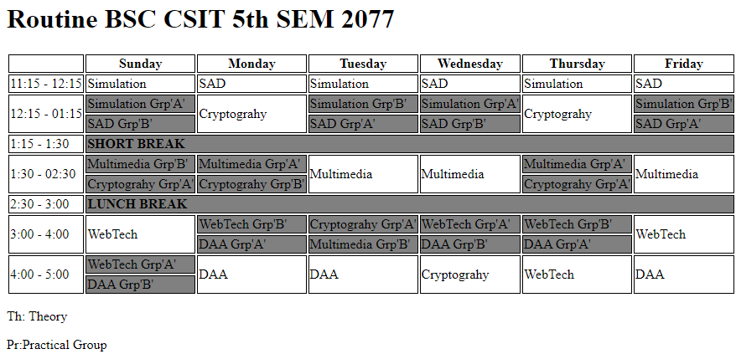

1. Create the registration form in HTML. Your form should include tables, file browsing, and all other form elements: Textbox, Password, Radio-button, Checkbox, Dropdown list, button, text- area and so on.

<!DOCTYPE html>

<html>

<head>

    <title>Registration Form</title>

    <style>

        table

        {

            border-radius: 10px;

            border-style: groove;

        }

    </style>

</head>

<body>

    <form action="process_registration.php" method="post" enctype="multipart/form-data">

        <table>

            <th >Registration Form</th>

            <tr>

                <td>Name:</td>

                <td><input type="text" name="name" required></td>

            </tr>

            <tr>

                <td>Email:</td>

                <td><input type="email" name="email" required></td>

            </tr>

            <tr>

                <td>Password:</td>

                <td><input type="password" name="password" required></td>

            </tr>

            <tr>

                <td>Gender:</td>

                <td>

                    <input type="radio" name="gender" value="male" required> Male

                    <input type="radio" name="gender" value="female" required> Female

                </td>

            </tr>

            <tr>

                <td>Interests:</td>

                <td>

                    <input type="checkbox" name="interests[]" value="sports"> Sports

                    <input type="checkbox" name="interests[]" value="music"> Music

                    <input type="checkbox" name="interests[]" value="travel"> Travel

                </td>

            </tr>

            <tr>

                <td>Country:</td>

                <td>

                    <select name="country">

                        <option value="us">United States</option>

                        <option value="ca">Canada</option>

                        <option value="uk">United Kingdom</option>

                    </select>

                </td>

            </tr>

            <tr>

                <td>Profile Picture:</td>

                <td><input type="file" name="profile_picture"></td>

            </tr>

            <tr>

                <td>Address:</td>

                <td><textarea name="address" rows="4" cols="50"></textarea></td>

            </tr>

            <tr>

                <td colspan="2"><input type="submit" value="Register"></td>

            </tr>

        </table>

    </form>

</body>

</html>

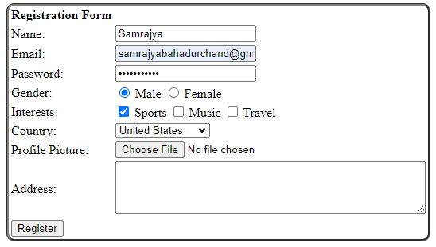OUTPUT

1. Implement different HTML Events: Windows Event, Keyboard Event, Mouse Event and Form Element Event.

<!DOCTYPE html>

<html>

<head>

    <title>HTML Events Example</title>

    <script>

        // Window Event

        window.onload = function() {

            alert('The page has loaded!');

        };

        window.onresize = function() {

            document.getElementById('resize-info').innerHTML = 'Window resized!';

        };

        // Keyboard Event

        document.onkeydown = function(event) {

            alert('Key pressed: ' + event.key);

        };

        // Mouse Event

        document.getElementById('my-button').onclick = function() {

            alert('Button clicked!');

        };

        document.getElementById('my-div').onmouseover = function() {

            document.getElementById('mouse-info').innerHTML = 'Mouse over the div!';

        };

        // Form Element Event

        function showValue() {

            var inputElement = document.getElementById('text-input');

            var value = inputElement.value;

            alert('Input value: ' + value);

        }

    </script>

</head>

<body>

    <h1>HTML Events Example</h1>

    <!-- Window Event -->

    <div id="resize-info"></div>

    <!-- Keyboard Event -->

    <p>Press any key to trigger the event.</p>

    <!-- Mouse Event -->

    <div id="my-div">Hover over me</div>

    <p id="mouse-info"></p>

    <button id="my-button">Click me</button>

    <!-- Form Element Event -->

    <input type="text" id="text-input" placeholder="Type something...">

    <button onclick="showValue()">Show Value</button>

</body>

</html>

OUTPUT

**WINDOW EVENTS**

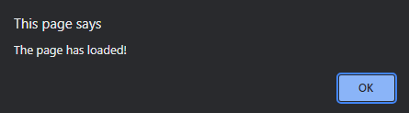



**MOUSE EVENTS**

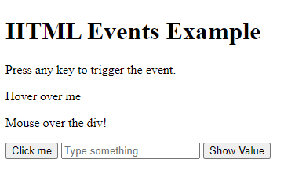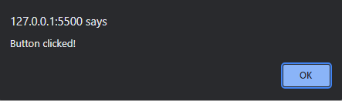

**KEYBOARD EVENTS**

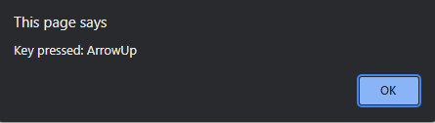

**FORM EVENTS**

